**PROBLEM STATEMENT :**

**Implicit Cursor**

**QUE1. The bank manager has decided to activate all those accounts which were**

**previously marked as inactive for performing no transaction in last 365**

**days. Write a PL/SQ block (using implicit cursor) to update the status of**

**account, display an approximate message based on the no. of rows**

**affected by the update. (Use of %FOUND, %NOTFOUND, %ROWCOUNT)**

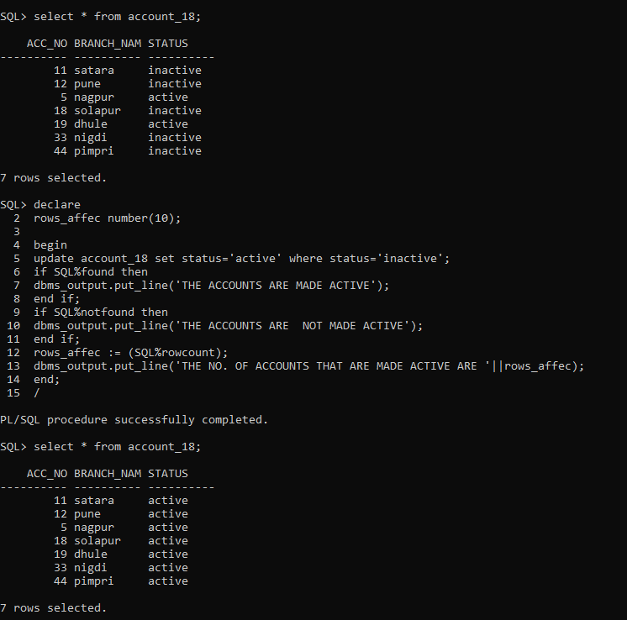

**2. EXPLICIT CURSOR:**

**2. Organization has decided to increase the salary of employees by 10% of existing salary, who are having salary less than average salary of organization, Whenever such salary updates takes place, a record for the same is maintained in the increment_salary table. EMP (E_no , Salary) increment_salary(E_no , Salary)**

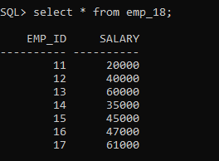

declare

cursor cr_emp is select emp_id,salary from emp_18 WHERE salary < (SELECT AVG(salary) FROM emp_18);

memp_id emp_18.emp_id%type;

msalary emp_18.emp_id%type;

begin

open cr_emp;

if cr_emp%isopen then

loop

if cr_emp%found then

update emp_18 set salary=salary+(salary*0.1) WHERE salary < (SELECT AVG(salary) FROM emp_18);

fetch cr_emp into memp_id,msalary;

exit when cr_emp%notfound;

insert into increment_18 values(memp_id,msalary);

end if;

end loop;

end if;

close cr_emp;

end;

/

**QUE3. Write PL/SQL block using explicit cursor for following requirements:**

**College has decided to mark all those students detained (D) who are having attendance less than 75%. Whenever such update takes place, a record for the same is maintained in the D_Stud table.**

**create table stud21(roll number(4), att number(4), status varchar(1));**

**create table d_stud(roll number(4), att number(4));**

